Sukkur IBA University

Kandhkot Campus

**Software Requirement Specification (SDS)**

**For**

**YHEW Food Delivery Mobile Application**

By Sooraj Kumar

Supervisor:

Muhammad Faiz Lakhani

Contents

**Introduction of the Document** 2

**Use Case Diagram** 3

**Architecture Design Diagram** 4

**Sequence Diagrams 5**

**Activity Diagram:** 6

**Class Diagram 7**

**Interface Design Diagram** 8

# **Introduction of the Design Document**

**1.1 Purpose of this Document**

The Purpose of this document is to provide detailed insights of the project. It also clarifies the components of this project of how they work and how the application flows and how they interact among themselves.

This document contains the diagrams like Sequence Diagram, Activity Diagram, Use Cases and State Diagram which will clarify the project scope, its models and internal functionality.

**1.2 - Scope of Document**

For this final year project, this project is based on the food category. This project has multiple roles as sellers, admin and customers. This document explains the detailed scenarios and the flow of the app and its architecture. This document is all about the working scenarios and test cases.

# **Entity Relationship Diagram (ERD)**

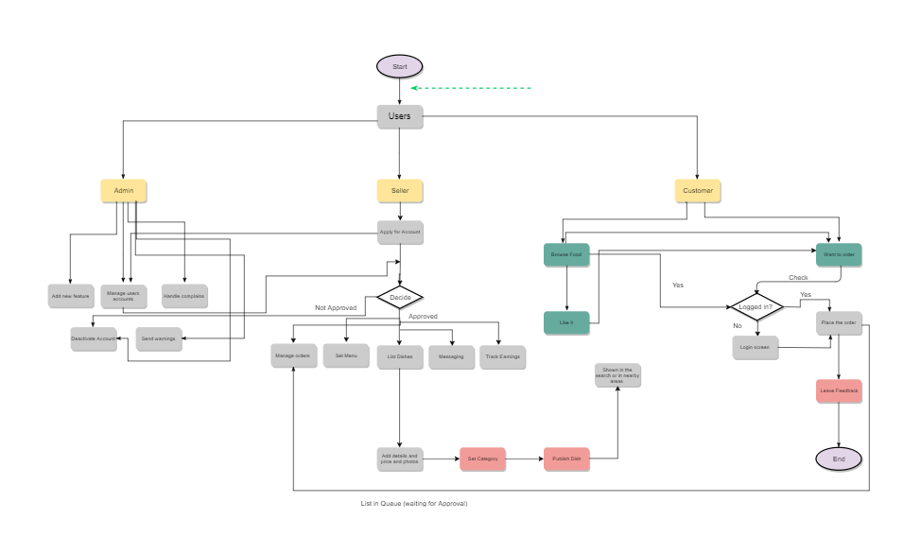

# **Sequence Diagrams**

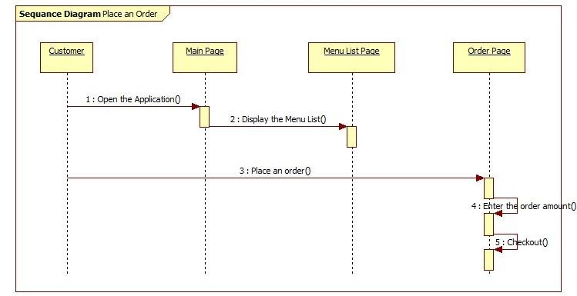

# **Architecture Design Diagram**

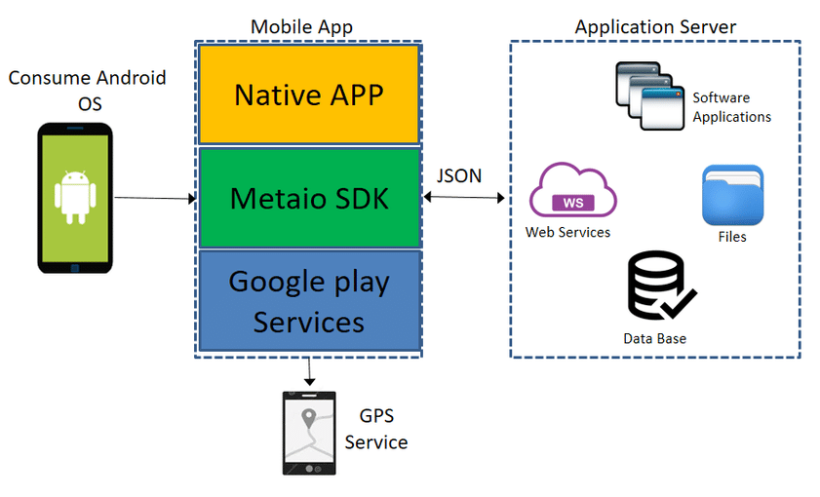

# **Database Diagram**

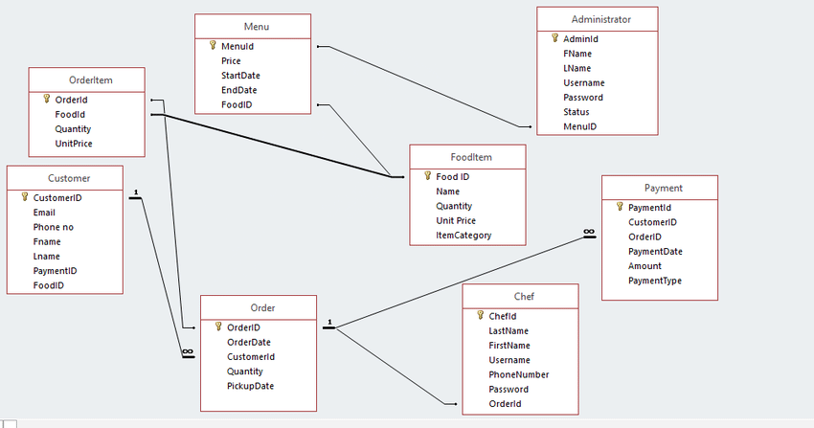

# **Class Diagram**

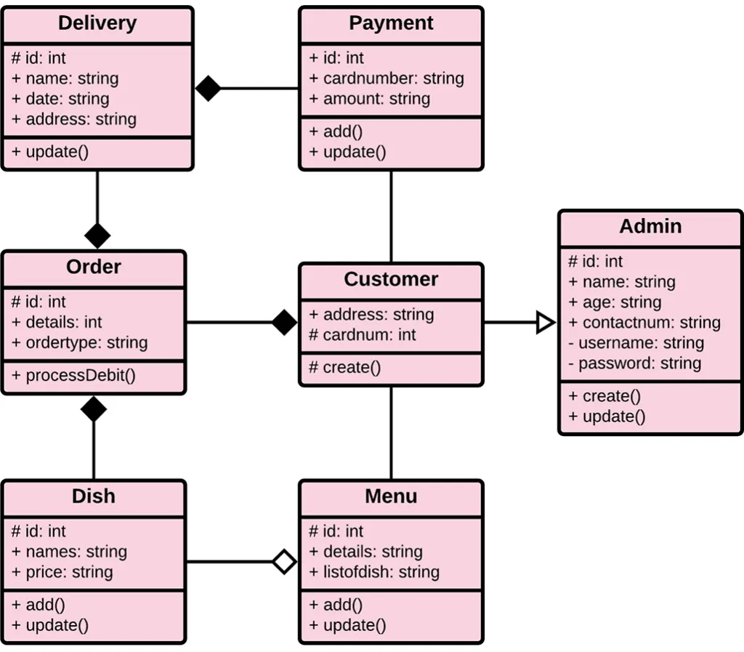

**Use Case Diagram**

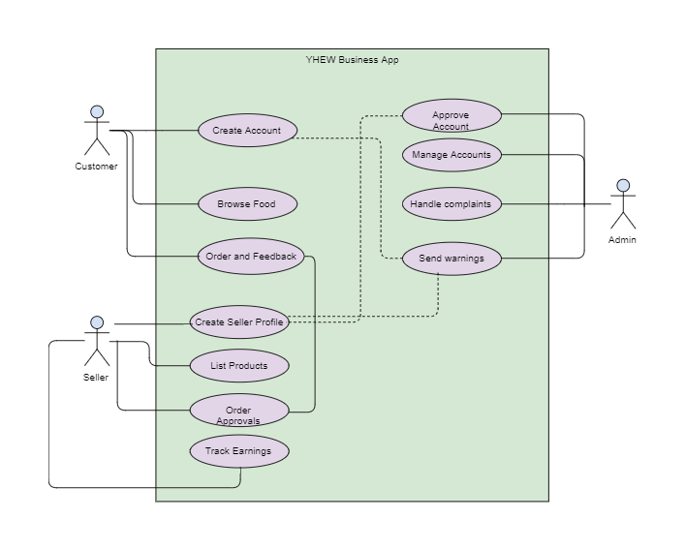

# 

# **Interface Design Diagram**

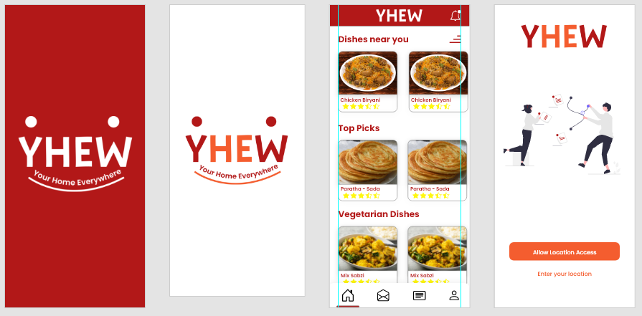

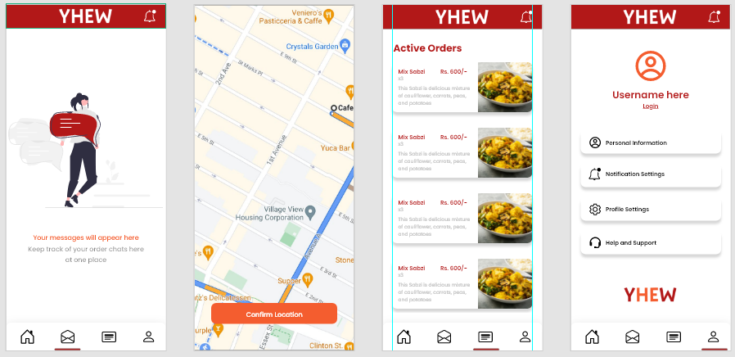

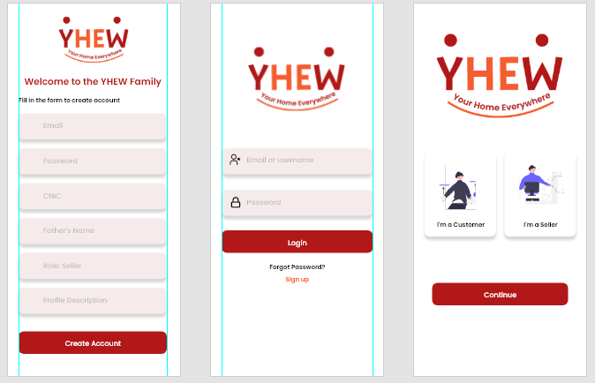

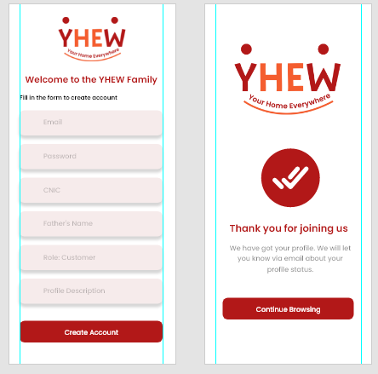

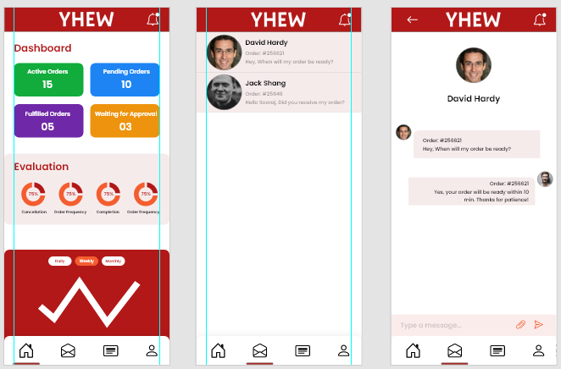

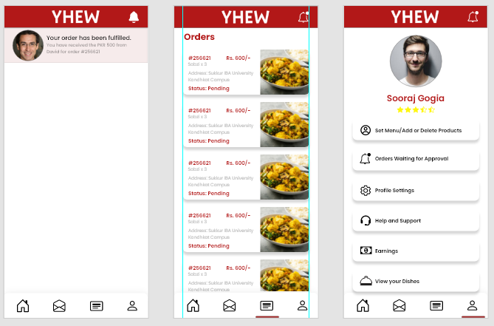

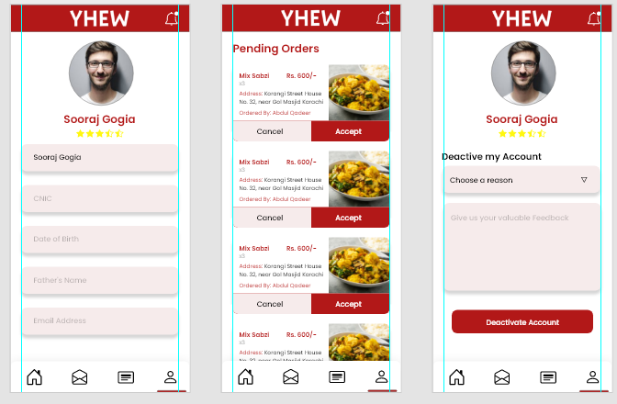

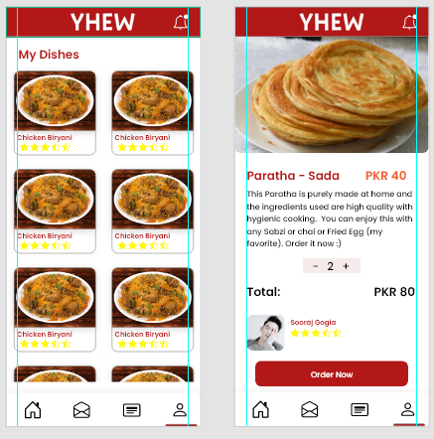

Test case sample

<https://i0.wp.com/synapse-qa.com/wp-content/uploads/2020/03/test-case-example1-1.jpg?resize=535%2C381&ssl=1>